Laborator 5 - Mobile Networks Security

Inspect your phone. Respond to the following questions:

1. What network(s) are you connected to?

2. What generation is your phone currently using (2G/3G/4G)? What indicates you the generation?

3. Does your phone has an option to disallow connecting to old generations (e.g., only use 5G or 4G)?

4. Are you in roaming? What indicates you roaming?

5. Are you using mobile data? What indicates if you use your mobile data or your WiFi?

Inspect your phone. Respond to the following questions:

1. Which is (are) your IMEI(s)? How did you find the value(s)?

2. Which is (are) your IMSI(s)? How did you find the value(s)? Are the MCC and MNC corresponding to the correct ones, according to http://www.mcc-mnc.com/ ?

3. Which is the MAC address of your phone?

4. Which is (are) the IP address(es) of your phone? Which is the network mask?

5. Is it an IP address v4 or v6? Why do you think this is?

Exemplify with at least two security aspects that are set for your phone (e.g., related to access control, confidentiality of data, etc.).

Explain why these aspects are useful and what do they protect against (what could go wrong if they are not in place?).

Inspect the capture file abis-accept-network.pcap available at <https://wiki.wireshark.org/SampleCaptures#GSM> . Take care! Set "Use GSM SAPI Values" in LAPD preferences.

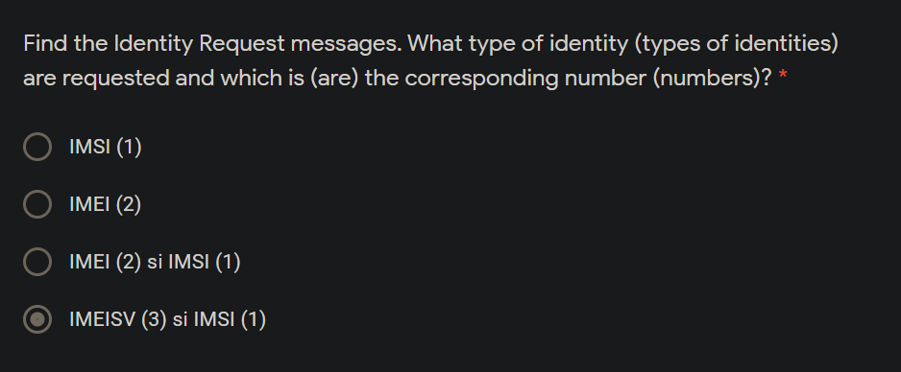

The information about the public key is visible under Public Key Info.

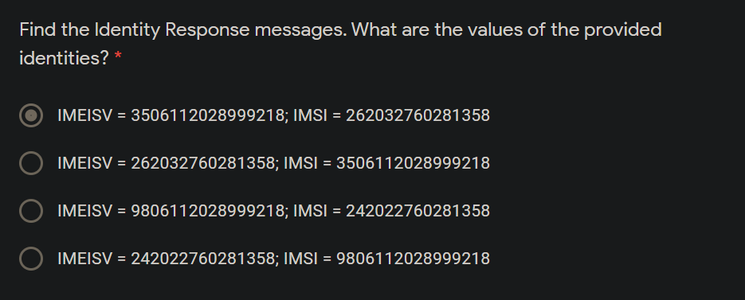

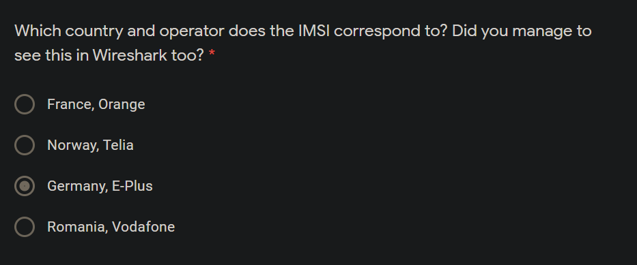

Inspect the capture file abis-reject-network.pcap available at <https://wiki.wireshark.org/SampleCaptures#GSM> . Check the allocation of the temporary identification to the user.

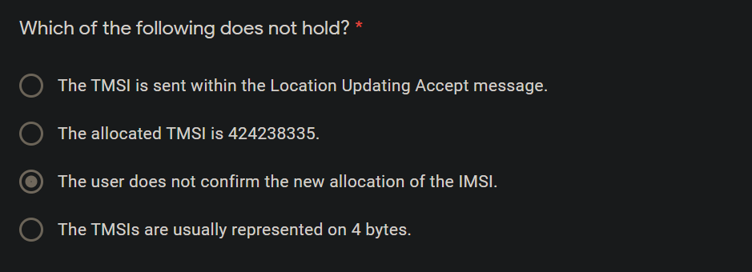

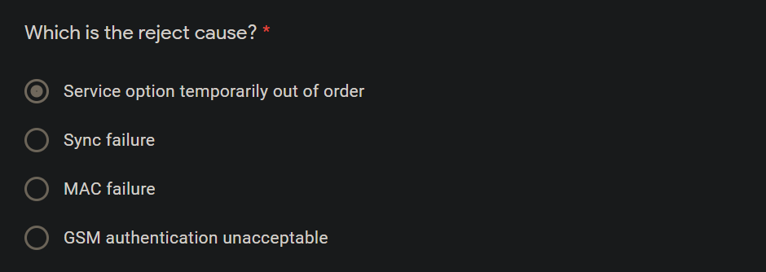

If you inspect the capture, you will find information about Mobile Station Classmark 1, 2, and 3. Mobile station classmarks are information elements that provide information about the capabilities of the mobile station. You can read more information about the mobile station classmarks in the standards or online, e.g., <http://llazvii.top/GSM_GPRS_EDGE_Mobilestationclass.html>

